## Problem

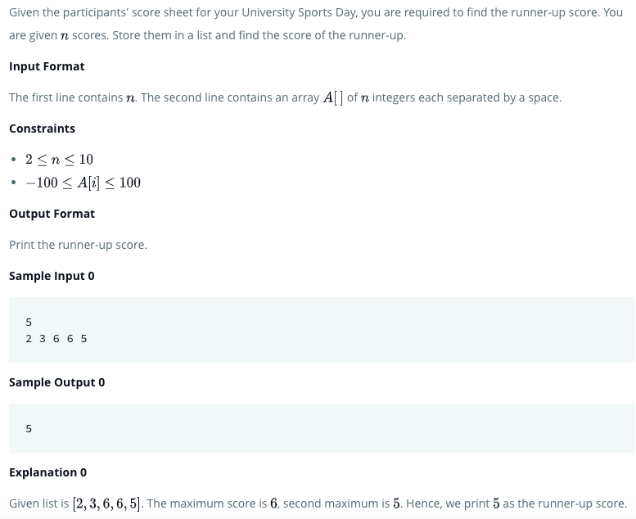

## Solution

if __name__ == '__main__':

    n = int(raw_input())

    arr = map(int, raw_input().split())

my_list = []

for i in arr:

    if i < max(arr):

        my_list.append(i)

print(max(my_list))

## Python3

if __name__ == '__main__':

n = int(input())

arr = map(int, input().split())

arr = list(arr)

x = max(arr)

y = -9999999

for i in range(0,n):

if arr[i]<x and arr[i] > y:

y = arr[i]

print(y)